Aum sri Sairam

Placement cell management

Problem statement

**Problem statement**

· Placement cell management deals with the placement of students in companies ,helps students to know about industry and training the students for the placement. manages application of students ,college of student , type of job for student.Placement cell management have to see all the records of the student to give placement and it is time consuming task to search for all the records and we may find error in that and sorting is the main problem among the students.

Placement cell management will have different classes and their attributes .Entities of placement are linked with each other and they have unique ID .

* · There will be certain details of student with the college who applied for the placement which have their attributes id of applicant ,name of applicant ,mobile number of applicant, address,email of applicant which will have unique id .
* · Each college which is providing the placement will consist of the attributes college id , name of the college, address of college and courses it offers to student.
* · Placement staff manages the placement with attributes placement id and qualification requirement with a placement officer.
* · Different companies come to the college for placement of students bringing up the job for them and their attributes are job id, company name , job name ,salary that will be given by the company.
* · There are training camps for the students and there are attribute for training which are training id , training name, training period.

**Entities-**

* Student (Person)
* College(Place)
* Placement(Concept)
* Job(Event)
* Training(Event)

**Attributes for my Entities**

| **Entity type** | **Attribute** | **Type** |
| --- | --- | --- |
| Student  (strong) | Student_id(primary key)  Name  Mobile number  Address  Email | Simple  Composite  Multivalued  Composite  Simple |
| College  (strong) | College_id(primary key)  Name_of_college  Address_of_college  Courses | Simple  Simple  Composite  Simple |
| Placement | placement_id  qualification_requirement | Simple  Simple |
| Job  (strong) | job_id(primary key)  company_name  job_name  salary | Simple  Simple  Multivalued  Simple |
| Training | training_id  training_name  training_period | Simple  Simple  Simple |

**Relationship for my entities**

* Student (Person)
* College(Place)
* Placement(Concept)
* Job(Event)
* Training(Event)

**ER diagram for the placement cell management**

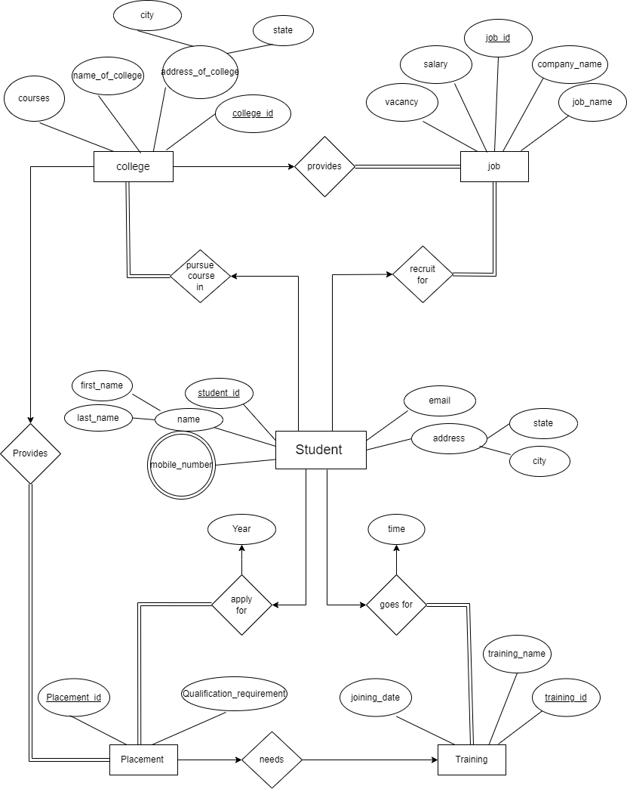

**Normalisation**

Table selected to find the normalization is **JOB** relation

1nf- decomposition



Steps:

1. identify the prime and non-prime attributes

2. check if the candidate key is a composite key.

3. check if the non-prime attributes are fully dependent on the prime attributes.

4. check if the non-prime attribute is partially dependent on the prime attributes.

->This relation is already in 1-NF form because no multivalued attribute(atomic)

>The key for this table is (job_id,college_id,student_id) and in this college_id and student_id are the foreign keys and job_id is the primary key in the table.

->The Functional dependency are F={aef -> bcd }

-> {bcd} may have redundant values so they won’t form the key.

->Prime attributes are {aef}

->Non- prime {bcd}

checking for partial dependency

a -> b / e -> b / f -> b

a -> c/ e -> c/ f -> c

a -> d/e -> d/ f ->d

Non prime attributes are partially dependent of the part of primary key.

2nf decomposition

a -> b / e -> b / f -> b

a -> c/ e -> c/ f -> c

a -> d/e -> d/ f ->d

CONVERTING INTO 2NF

All the above 9 functional dependencies are creating problem because there are non-prime attributes are in partially dependent on the candidate key.

So the new relations are:

1.(job_id,company_name)

2.(job_id,job_name)

3.(job_id,salary)

4.(student_id,company_name)

5.(student_id,job_name)

6.(student_id,salary)

7.(college_id,company_name)

8.(college_id,job_name)

9.(college_id,salary)

**3NF FORM: -**

Conditions for this are:-

* Already in 2NF
* NO transitive Dependency

In the above relation there are no transitive dependency in the relations so the given

Relation already in 3nf form.